The Sims 2
Reviewer’s Guide

Availability: September 17, 2004

Operating Systems: Windows® XP, Windows Me,
Windows 2000 and Windows 98

Estimated Retail Price: $49.99

ESRB Rating: “T” for Teen

Publisher: Electronic Arts
209 Redwood Shores Parkway
Redwood City, CA 94065

Developer: Maxis
209 Redwood Shores Parkway
Redwood City, CA 94065

Direct Sales: (877) 324-2637

Customer Service: (650) 628-4311

Hint Line: (900) 288-HINT

Web Site: http://www.sims2.com

http://www.info.ea.com
Visit for the latest press information and game assets.

PR Contact: Alex Skillman
650-628-7362
askillman@ea.com

PC System Requirements
600MHz, 256MB RAM, 32MB T&L video card. Win XP, ME, 2000, 98
If you have a T&L capable video card with at least 32 MB of video RAM then you need at least:
- 800 MHz processor or better
- 256 MB RAM if Windows XP, Windows ME, Windows 98 or Windows 2000
- At least 3.5 GB of hard drive space

If you have a non-T&L capable video card (an Intel Extreme Graphics or a Radeon 7000/VE Series) then you need at least:
- 2.0 GHz processor or better
- 256 MB RAM if Windows XP, Windows ME, Windows 98, or Windows 2000
- At least 3.5 GB of hard drive space
Get the most current driver for your video card. The manufacturers usually have the video drivers on their sites for you to download. Visit the nVidia site, the ATI site or the support site for your computer's manufacturer for the latest drivers for those video cards.
Supported video cards (and the more video memory the better):
- ATI RadeonTM series (7000 or better)
  - Radeon 7000/VE series (non-T&L; requires 2.0 GHz processor)
  - 7200, 7500
  - 8500, All-In-Wonder 8500
  - 9000, 9200, 9500, 9600, 9700, 9800
  - X300, X600, X800
- Nvidia® QuadroTM series
  - Quadro, Quadro2, Quadro4
- Nvidia® Geforce series (GeForce2 and better)
  - GeForce2
  - GeForce3, 3 Ti
  - GeForce4, 4Ti, MX 420, 440
  - GeForce FX 5200, 5600, 5700, 5800, 5900, 5950
  - GeForce 6600, 6800
- Intel® Extreme Graphics (non-T&L; requires 2.0 GHz processor)
  - 82845, 82865, 82915

Description

The Sims™ changed the face of gaming in the new millennium and quickly became the #1 PC game of all time. In the next generation sequel of The Sims, The Sims™ 2, you control your Sims over an entire lifetime for the first time. With the ground-breaking addition of genetics, your Sims now pass their DNA down through generations giving you a more vivid and in-depth Sims experience. Every life choice you make has a relevant and dramatic effect on the lifetime of your Sim. It’s up to you to take your Sims from the cradle to the grave, fulfill their dreams, and push them to extremes in The Sims 2.

Key Features
- Genes: Direct your Sims through a lifetime and determine their evolution as they pass on genetic traits from one generation to the next. Sims in The Sims 2 now have DNA and inherit physical characteristics and personality traits . They both resemble and behave like their ancestors. Direct your Sims from infancy through childhood, teenage life, and adulthood. Take them through an infinite number of generations and evolve your Sims family tree.

- Dreams: You set your Sims’ goals in life including fame, fortune, family, knowledge or romance. Will they be a lover or a loser? A prince or a pauper? A fool or a mastermind? Give them what they want and they’ll lead a long successful existence. Indulge in their fears and ruin their life.
- Extremes: Will your teen Sim get busted by the cops? Will your Sims work their way to riches, marry money, or inherit their fortune? In The Sims 2, you take your Sims to extremes. Witness the big and extreme moments that make every Sims' life uniquely memorable.
- Unleash Creativity: The Sims 2 will open up endless new creative possibilities. Make your own Sim films with the new movie making feature. Create the cast, set the stage, take control of the camera and capture your own screenplay in action. Zoom in close with the new camera to see every last detail. Generate unique Sims with the new “Create-A-Sim” packed with a vast selection of facial features, hairstyles, and outfits. Gain easy access to player made content and open up endless customization options. Create dream homes and design neighborhoods with the new building, design, and home furnishing options.

A Quick Guide to Getting Started in The Sims 2

*FOR INSTRUCTIONAL USE ONLY, NOT FOR REPRINT OF ANY KIND*

The Sims 2 is already set-up with 3 Shipping Neighborhoods that allow you to experience all the new gameplay of playing Sims across their lifetimes and fulfilling their dreams. It’s still a game that’s built around the personal storytelling of the player, and you’ll definitely want to make your own Sims and start from scratch later, but this is a good way to get into the action quickly.

Each of the neighborhoods contains unique stories and family situations that highlight the dynamics and variety of Sims life.

To get you started quickly there are several houses that we recommend checking out.
---------------------------------------------------------------------------------------------------------------------

Romance: Don Lothario – Pleasantview (Neighborhood 1)
Don is a “player.” He’s been playing every woman in the neighborhood. How does he maintain all those relationships? Even with the Maid (NPC’s are now fair game).

This is the best house to jump into to quickly to get the experience of fulfilling some high level Wants. And also experience some of the cool cinematics.
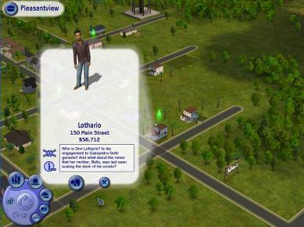

Gameplay Note: All of the Wants in the Wants Panel are clickable, so if you aren’t sure how to achieve them, just click. You also want to avoid the Fears.
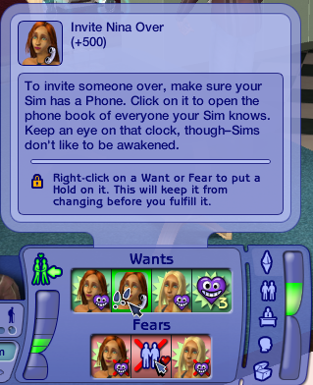

Gameplay Note: Each of the houses also provides some helpful tips to get you started.
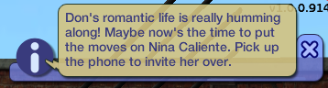

Since two of the Wants in the panel involve Nina it’s a strategic move to Invite her over. Make sure to Greet her when she arrives.

The “Ask to Join” interaction is key for fulfilling some of Don’s wants. Once his girlfriends are over, have them “Join” Don on the bed or in the tub to fulfill those Wants.
---------------------------------------------------------------------------------------------------------------------

Wealth: The Caliente Sisters – Pleasantview (Neighborhood 1)
Nina and Dina have money on their mind, and their Wants reflect that fact. Earning simoleans is the focus of this household.
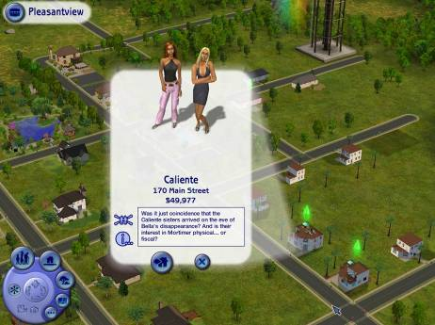

Dina has been working on marrying into Money rather than earning it herself. She’s got a healthy relationship already going with Mortimer Goth. It’s now time to take it to the next level. Fortunately he’s already on his way over, all you have to do is Greet him when he arrives. 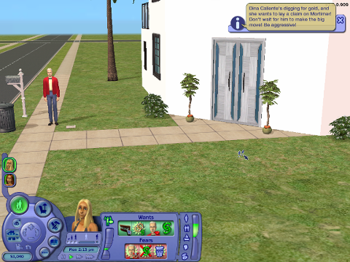

Gameplay Note: If you score some of the really big wants, you will push your Sim into Platinum mode. This is max mood for your Sims, so it’s an excellent time to work on skill building, and if you can send your Sim off work in this state, a promotion is almost guaranteed.

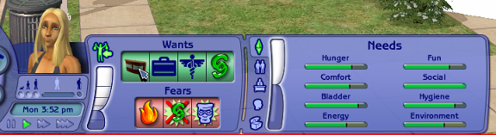

---------------------------------------------------------------------------------------------------------------------

Popularity: The Smith Family – Strangetown (Neighborhood 2)
Johnny is not like the other kids, and he just wants to fit in – make friends, have parties, be known.
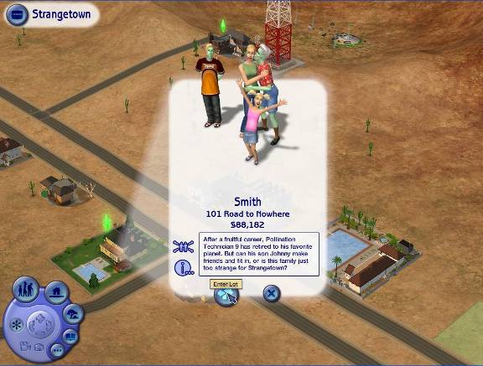

Johnny is about to grow up, all he needs is a successful party to start off Adulthood on the right foot. The phone let’s you bring over the neighbors to help celebrate.
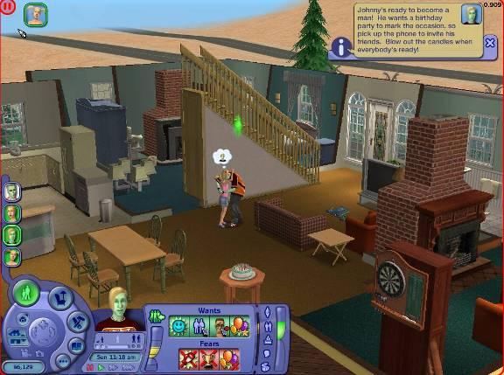

Having a good party requires a lot of socialization with your guests. The better they get to know each other, the better the party. Johnny is very close to becoming friends with Ripp Grunt, so he’s a good choice to help Johnny fulfill his “Make Friend” Want too.
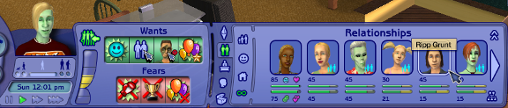

---------------------------------------------------------------------------------------------------------------------

Knowledge: The Curious Brothers – Strangetown (Neighborhood 2)
The Curious Brothers have spent their lives pursuing knowledge. That pursuit has resulted in some surprising events.
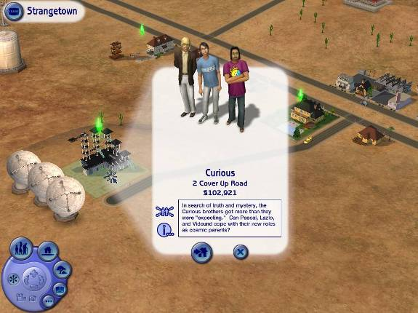

Vidcund really wants to see a UFO, the telescope on the second floor is good for fulfilling this want. All of the brothers also want to gain new skills so it’s easy to find ways to fulfill their Aspirations.
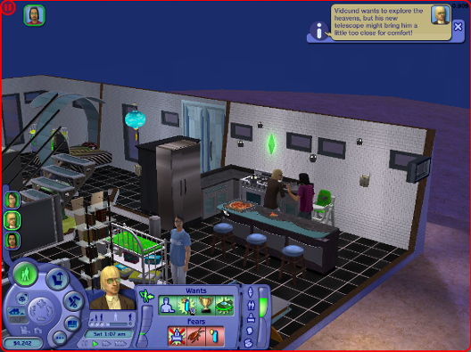

Pascal has put on a little weight, and it all seems to be since the last time he went looking for Aliens. Wonder what that is all about.
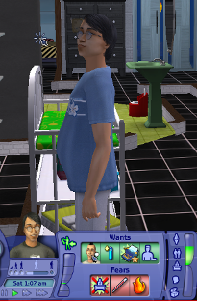
------------------------------------------------------------------------------------------------------------

Family: The Broke House – Pleasantview (Neighborhood 1)
Brandi is living life as a single mom, and doing her best to make sure her sons grow up right. Both Dustin and Beau need a lot of her attention.
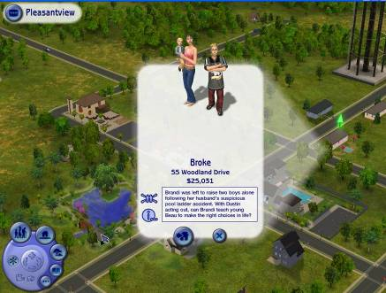

Toddlers need to be taught well to ensure they fulfill their “Grow Up” Aspiration. If Brandi spends some time helping Beau, she will also fulfill some of her own Wants.
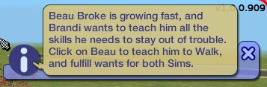

Gameplay Note: Once a Sim has fulfilled a few wants, they can purchase Reward Objects to help achieve other Wants more easily. Having Brandi purchase the Smart Milk Reward Object is a great way to help ensure Beau grows up well. Just put it on the counter and put it to good use.
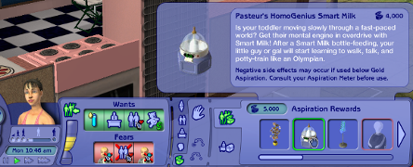

Brandi has a little surprise waiting for her, when she finds out #3 is on the way. Helping raise her kids while preparing for a third is great challenge. It’s important to watch her Needs as well as her Wants as pregnancy can take a lot of out you.
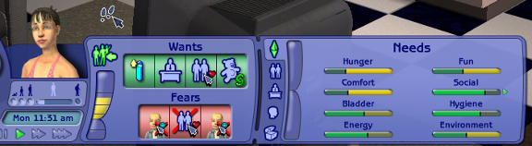

------------------------------------------------------------------------------------------------------------

Starting Your Own Story

Create A Family
This is the button to click if you want to make your own Sims rather than playing with ones that we have created.
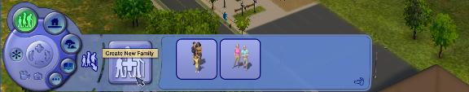

Create A Sim is meant to be explored, but there are few concepts/features which you should be aware of.

Tab 3 – Face Creation
This is the tab where you can change and modify the genetic features of your Sim. There are premade Sims available on Tabs 1 and 2, but this is the tab where you can really play with what they look like. Each of the Face Icons reveals a different portion of the face.
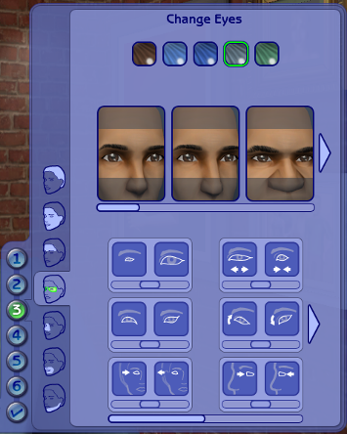

- Left-clicking on the facial images will change the portion of the face to the image shown.
- Right-clicking on the facial images will slowly blend toward the face
- Pull the sliders below the icons change individual features.

Tab 6 – Aspiration and Personality Selection
You must select an Aspiration for your Sim before exiting Create A Sim, clicking on the Icon shows you some of the key wants the Sim will have.
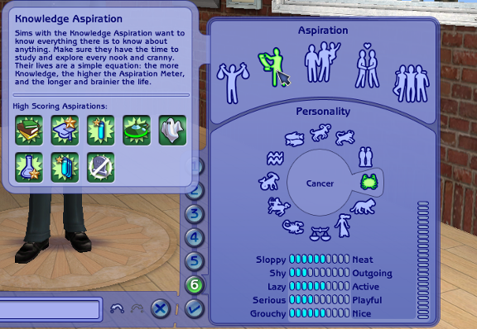

Once you have an Adult Male and Female made you now have the option to make a genetic child from the two of them
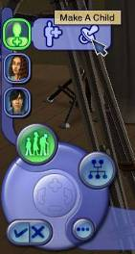

Click the Pacifier button in the center to generate random offspring, you can select their sex, and age from the panel at the left.
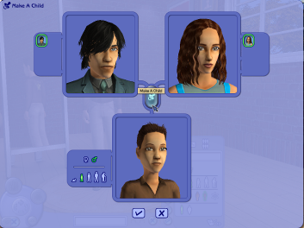

After you have created the Sims for your Family, Select the Family Tree button to arrange their relationships. Click on the faces and drag and drop them on one another to create the tree.
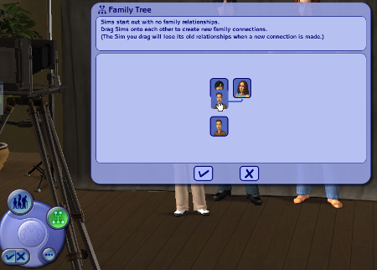

Upon exiting Create A Family, the family will be attached to your mouse and you select any of the highlighted lots for them to move into.
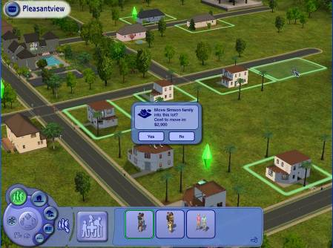

------------------------------------------------------------------------------------------------------------

Buy and Build Modes
There are so many upgrades to the features in Buy and Build mode, the best way to experience them is to experiment, but there are few that should be mentioned specifically. Use them all to build the homes of your Sims dreams.

Foundations and Decks
This tool allows you to build your homes off the ground, and is new to The Sims 2. It allows for some of the most dynamic homes in the game to be built.

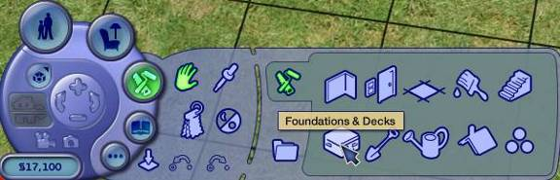
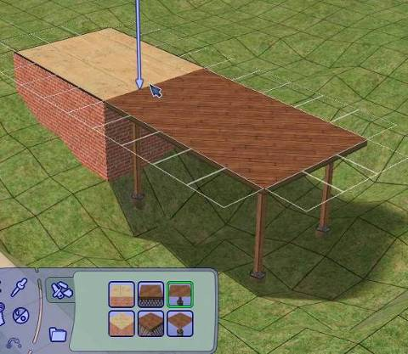

Connecting Stairs
Found under the Stair Tool, this tool allows you to connect you foundations to the ground.
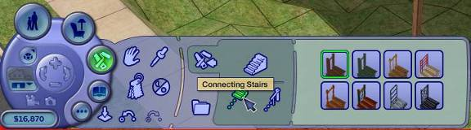
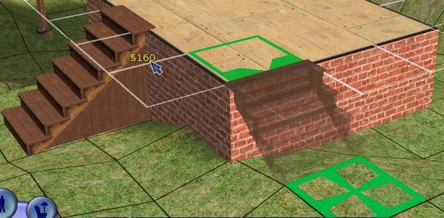

Eye Dropper Tool
This tool allows you to click on any placeable object or texture and immediately jump to it in the catalog, an incredible time saver and for the player with hundreds or thousands of custom content elements, the most useful tool in the entire game.
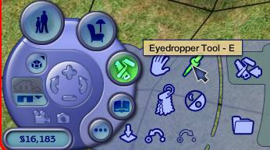

Design Mode
When you place objects many of them allow you to select from a variety of fabric and material choices.
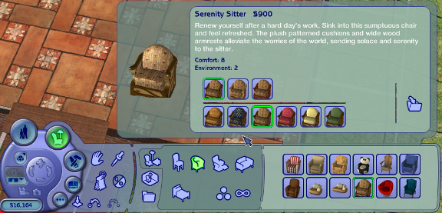

After and object is placed you can use the Design Tool to change the selections.
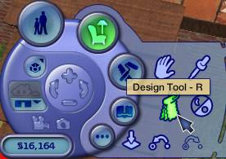

Collections
Collections allow the player to group together objects and wall and floor coverings of specific styles. They are a great way to decorate rooms with all the right stuff.


